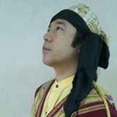
Saskatoon International Folkdance Club is proud to
introduce Yoshinari Murakami
from Setagaya, Tokyo, Japan
in his first seminar in North America
March 29-31, 2019 in Saskatoon Saskatchewan
Albert Community Centre Auditorium, 2nd Floor , 610 Clarence Avenue

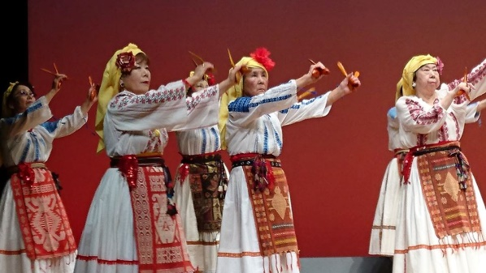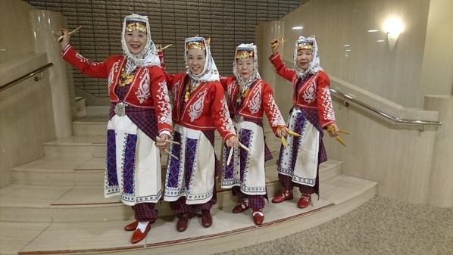

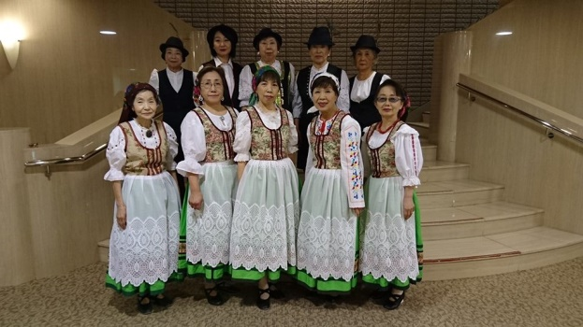

As well as leading and playing music for a recreation folkdance group in Japan, he has lead seminars in Turkey and Japan. He has expertise in dances from
Turkey, Armenia, Bulgaria, Japan and many more. Yossie is the director of a well respected performing group, Nihon Folk Dance Federation

For more information damcqueen@shaw.ca
Mail registrations to Saskatoon International Folkdance Club
c/o Dorothy McQueen, 331 Costigan Cres. Saskatoon Saskatchewan S7J 3P2

Registration Form: Please return as soon as possible

Name:__________________________________________

Address:______________________________P.C-__________

Phone:__________________________________________

E-Mail:__________________________________________

I will attend the whole workshop $125.________
or
I will attend session(s)$45/session- Session 1(Friday evening)___________
Session 2(Saturday morning)_________
Session 3 (Saturday afternoon)________
Saturday evening meal? (price not include) yes_______no__________
(Let us know if you have any food allergies)

Are you interested in a CD of the music yes_______ no __________

Would you be interested in a DVD yes________ no __________
We have limited billets available, are you interested yes________
Mail completed registration form and/or payment to:
SIFC
c/o Dorothy McQueen
331 Costigan Cres
Saskatoon, Sask
S7J 3P2
OR
Complete registration form on line at sifc.awardspace.com
Local hotels:
Best Western East Side: Address: 3331 8 St E, Saskatoon, SK S7H 4K1 Phone:(306) 986-2400
(short drive down 8th to Clarence for 4 blocks $139/night, breakfast bar included)

Park Town Hotel: Address: 924 Spadina Crescent E, Saskatoon, SK S7K 3H5 Phone:(306) 244-5564
(over University Bridge and a short drive up Clarence $139/night) http://www.parktownhotel.com/

